Milton of Campsie Parish Church

Registered Scottish Charity No SCO14735

www.mocpc.org.uk

Intimations – October 2025

**October Retiring Offering**

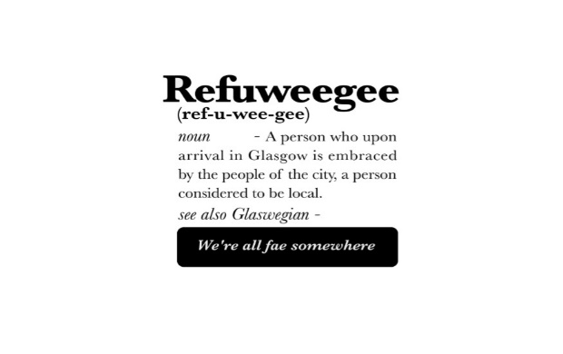Refuweegee was set up in December 2015 to provide a warm welcome to forcibly displaced people arriving in Glasgow.

Their aim is to enable the existing community in extending the friendly welcome that Glasgow is world renowned for. They do this through their welcome packs, their events and their volunteer opportunities. They try to provide everyone who wishes to get involved with an opportunity to do so; be it through writing a letter, donating essential items, joining them at an event or fundraising. They work with multiple organisations around Scotland, from their partners who distribute welcome packs through to schools and community organisations looking to do something similar in their area.

**October**

**Sunday 5th**  11.00 a.m. - Sunday Worship. Harvest Thanksgiving. Congregation vote on Union. See below for more details on both.

2.30 p.m. Autumn Concert in aid of Strathcarron Hospice with the Strathcarron Singers.

Mon 6th 9.45 a.m. Baby and Toddler Group

2.00 p.m. Hobbies Club

7.30 p.m. Badminton Club

Tue 7th 9.30 a.m. Café Connect

Wed 8th 7.00 p.m. Time to Pray, in The Eric Liddell

7.30 p.m. The Fellowship. Talk from Major Ray Brown, Work of the Salvation Army

**Sunday 12th**  11.00 a.m. Sunday Worship

12.45 p.m. – 1.45 p.m. Taking it Further, in the Eric Liddell. Bring a packed lunch!

Mon 13th 2.00 p.m. Hobbies Club

7.30 p.m. Badminton Club

Tue 14th 9.30 a.m. Café Connect

Wed 15th 2.00 p.m. The Guild meet, with Andy Lowdnes

7.00 p.m. Time to Pray, in The Eric Liddell

Thurs. 16th **The deadline for submissions for the next edition of The Messenger.** (see below)

**Sunday 19th** 11.00 a.m. Sunday Worship

2.20 p.m. Meet for Services at the Birdston Care Homes.

Mon 20th 9.45 a.m. Baby and Toddler Group

2.00 p.m. Hobbies Club

7.30 p.m. Badminton Club

Tue 21st 9.30 a.m. Café Connect

Wed 22nd 7.00 p.m. Time to Pray, in The Eric Liddell.

7.30 p.m. The Fellowship. Talk by Andy Mackenzie, “28 days to walk the world”

7.45 p.m. Teams Meet

**Sunday 26th** 11.00 a.m. Sunday Worship.

Mon 27th 9.45 a.m. Baby and Toddler Group

2.00 p.m. Hobbies Club

7.30 p.m. Badminton Club

Tue 28th 9.30 a.m. Café Connect

**Deadline for Intimations for November**

Wed 29th 6.00 p.m. Fish & Film Night

7.00 p.m. Time to Pray, in The Eric Liddell.

**Vote on Union with Campsie Church**

We will be voting on the Union with Campise PC.  We hope to have a good turnout for that.  Remember, you must be at the service to vote and your name must be on our Congregational Roll or the list of adherents.  Any questions about this, please email Margaret Burton and she’ll endeavour to help.

**The Kirk Session commends this Basis of Union to the congregation.**

**The Foodbank.**

At the time of writing, they were short of UHT Milk, Fruit juice, Instant cooking oil, pasta sauces and Hygiene items. If you want to check for updates go to [East Dunbartonshire Foodbank](https://eastdunbartonshire.foodbank.org.uk/give%20-help/donate-food/)

We will be collecting for them on the 5th of October as part of our Harvest Thanksgiving service. Specific needs will be emailed during the preceding week.

**Intimations**

Items for October Imitations should be sent to the following email address mocpchurch@gmail.com, by **Tuesday 28th October.**

**TEAMs**

Should you wish to be in touch with any of the TEAMs to make suggestions or flag up a problem the contact details until 22nd October are:

Teach Rhona Wyper [rhonawyper@gmail.com](mailto:rhonawyper@gmail.com)

Tell Jim Crawford [jimwilma17@yahoo.co.uk](mailto:jimwilma17@yahoo.co.uk)

Tend Wilma Crawford [jimwilma17@yahoo.co.uk](mailto:jimwilma17@yahoo.co.uk)

Transform Bert Main [main1304@btinternet.com](mailto:main1304@btinternet.com)

Treasure Joy Glennie [glenniejoy@gmail.com](mailto:glenniejoy@gmail.com)

**The Messenger**

The deadline for submissions for the next edition of The Messenger is 16th October.

The TELL Team are compiling a list of people willing to deliver the magazine which should be ready about the 16th November. If you can help with this, please contact Robert Scott([rbrt1209@sky.com](mailto:rbrt1209@sky.com)) or any member of the Tell Team.