Sunday | Opening Prayer | Reader | Offering and intercession
5th Oct | Gillian Murphy | Wilma Crawford | Margaret Brown
12th Oct | Jackie Scott | Ann Good | Margaret Burton
19th Oct | Bill Forrest | Jean McDonald | Janice Alexander
26th Oct | Stephen Wallace | Roy Smith | Robert Scott
2nd Nov | Barbara Anderson | Alison Glen | George Kirkpatrick
9th Nov | Susie Colquoun | Ann Pert | Helen Jordan
16th Nov | Andrew McRae | George Good | Ruth Lang
23rd Nov | Christine McLachlan | Laurence Moody | Claire Mould
30th Nov | Yvonne Wallace | Kirsty Gallagher | Joyce Watt
7th Dec | Ellen McVean | Joan Darling | Wilma Crawford
14th Dec | Rhona Wyper | Grace Knight | George Good
21st Dec | Jennifer Love | Margaret Burton | Margaret Cowie
28th Dec | Jackie Scott | Tom Wilson | Maureen Gardiner

The reading and the prayers will be emailed to you, if possible, or printed and at the church by about 10.30am on Sunday morning.
If you are on the prayers after the sermon – i.e. offering and intercession, and feel comfortable writing your own offering prayer (or intercession, for that matter!), please let Phyllis (tomandphylmary@gmail.com) or Julie (jmoody@churchofscotland.org.uk) know. Sometimes it’s hard to write prayers for others to say – and the offering is a short one for you to work on.
When you are reading from the lectern, be there in advance and make sure you have correctly adjusted the microphone for your height.
Before you read, please remove your mask. Before each prayer say, ‘Let us pray.’ and when you have finished clean the lectern with an antiseptic wipe.
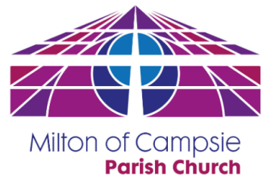
If you cannot help on the Sunday allocated to you or you are unhappy with what you have been asked to do, please arrange a replacement.
It is important that you change the rota which is in the Rotas’ Folder on the window as you enter the David Livingstone so the Duty Team leader knows of the changes and email or contact Phyllis or Julie to let her know of the changes.
Once again, many thanks for doing this.
George.

