Sunday | Opening Prayer | Reader | Offering and intercession
6th April | Gillian Murphy | Ann Pert | Margaret Brown
13th April | Ann Good | Anne Kirkwood | Margaret Burton
20th April | Bill Forrest | Jean McDonald | Janice Alexander
27th April | Stephen Wallace | Roy Smith | Robert Scott
4th May | Barbara Anderson | Alison Glen | George Good
11thy May | Susie Colquoun | Wilma Crawford | Helen Jordan
18th May | Andrew McRae | George Good | Ruth Lang
25th May | Christine McLachlan | Laurence Moody | Claire Mould
1st June | Yvonne Wallace | Kirsty Gallagher | Joyce Watt
8th June | Ellen McVean | Joan Darling | Wilma Crawford
15th June | Rhona Wyper | Grace Knight | George Kirkpatrick
22nd June | Jennifer Love | Ann Good | Jackie Scott
29th June | Margaret Cowie | Tom Wilson | Maureen Gardiner

The reading and the prayers will be emailed to you, if possible, or printed and at the church by about 10.30am on Sunday morning.
If you are on the prayers after the sermon – i.e. offering and intercession, and feel comfortable writing your own offering prayer (or intercession, for that matter!), please let Phyllis (tomandphylmary@gmail.com) or Julie (jmoody@churchofscotland.org.uk) know. Sometimes it’s hard to write prayers for others to say – and the offering is a short one for you to work on.
When you are reading from the lectern, be there in advance and make sure you have correctly adjusted the microphone for your height.
Before you read, please remove your mask. Before each prayer say, ‘Let us pray.’ and when you have finished clean the lectern with an antiseptic wipe.
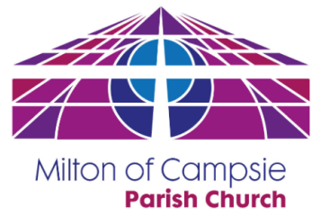
If you cannot help on the Sunday allocated to you or you are unhappy with what you have been asked to do, please arrange a replacement.
It is important that you change the rota which is in the Rotas’ Folder on the window as you enter the David Livingstone so the Duty Team leader knows of the changes and email or contact Phyllis or Julie to let her know of the changes.
Once again, many thanks for doing this.
George.

