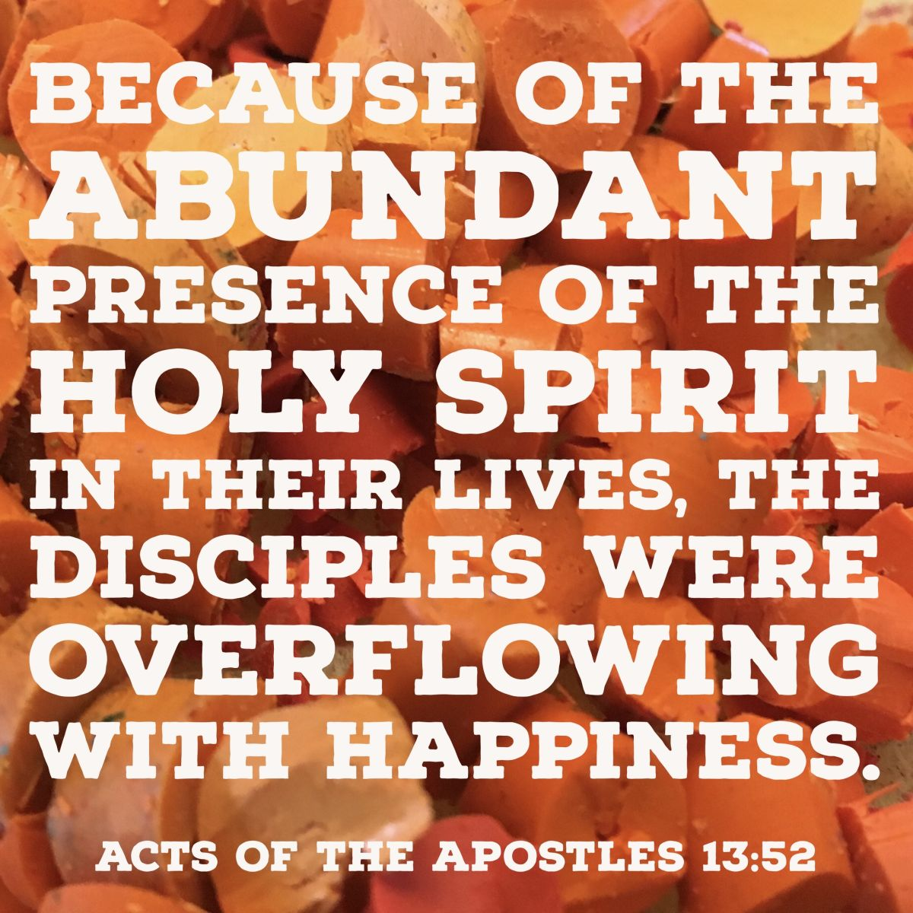

**TIF 010924. MoCPC Summer 2024**

**How did the Church grow?**

|  |  |  |
| --- | --- | --- |
| 26 May | Acts 2:42-47 | They witnessed transformed lives |
| 2 June | Acts 3: 1-11 | They saw a lame man walk |
| 9 June | Acts 8: 5-13 | They heard Philip preaching |
| 16 June | Acts 8:26-39 | God’s word was explained |
| 23 June | Acts 9:1-19 | A blinding light. (Communion) |
| 30 June | Acts 10:1-48 | Through a vision (Cornelius) |
| 7 July | Acts 16:1-15 | Being in right place at right time (Lydia) |
| 14 July | Acts 16:16-34 | Through crisis (Philippian jailer) |
| 21 July | Acts 18: 1-11 | Priscilla & Aquila |
| 28 July | GoMAD | Dedication |

Taking it Further 010924 - a further look at June/July

Opening Prayer:

Loving God, draw us closer to your heart, that we might know you better and understand you more completely.  From the security of what we know to the adventure of what you will reveal - **Lead us, we pray, in Jesus’ name – Amen.**

1. We skipped through the Book of Acts in 9 easy lessons. How do you feel?
2. It’s made me want to know more;
3. I remember very little of it;
4. It doesn’t seem to relate to the problems the church is facing today.
5. What did you learn from our journey through Acts?
6. Acts 15 (Philippian jailer) was an intergenerational service led by Jen from SBS.
7. How did you feel?
8. What did you learn?
9. We missed out quite a lot of Acts. Is there any particular event on which you would have liked to focus?
10. Acts 18 – Priscilla & Aquila

Did it surprise you to read about Priscilla preaching & working so closely with Paul?

How do you feel about the role of women in today’s Church?

1. Well done Luke!

An interesting fact - there’s no question that Paul wrote the most New Testament books. Things change, however, when you look at the word count. If you add up all the words Paul wrote, it comes to about 32,000. Definitely a respectable amount. But Luke wrote nearly 38,000 words (in just two books!), making him the author of about 27 percent of the New Testament. Paul, on the other hand, is responsible for about 23 percent.

Luke or Paul? Who has influenced you more? Why?

As we go – Holy Spirit of God:

**May your presence continue to enrich our debates, enlighten our world, and guide us in new directions. Amen**.